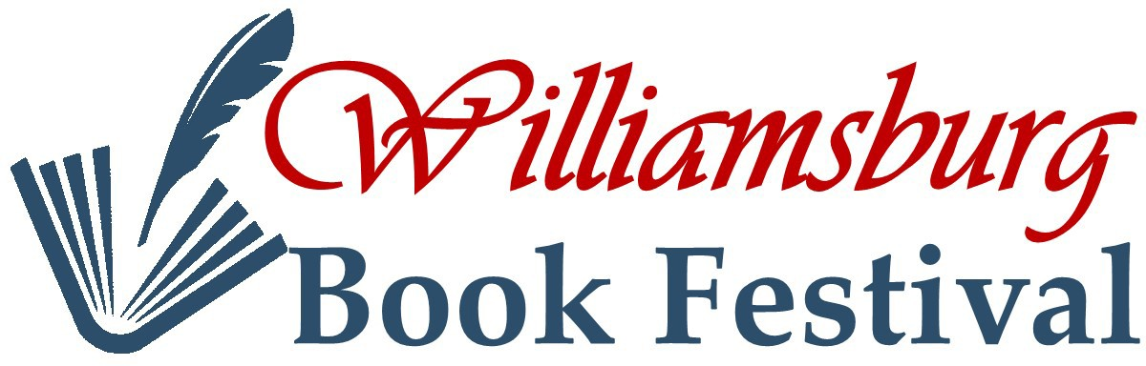2024

Sponsorships

|  |  |  |  |  |  |  |
| --- | --- | --- | --- | --- | --- | --- |
| **Sponsorship**  **Level** | **Website** | **Newspaper & Magazine Ads** | **Poster** | **Festival Handout** | **Writers Contest** | **Donation** |
| ***Event***  ***Sponsor*** | Logo & Link | Lead Logo  And Link  Brought to you  by: | Lead Logo  Brought to you  by: | Lead Logo  Brought to you  by: | N/A | $1,000 |
| ***Benefactor*** | Logo & Link | Logo | Logo | Mentioned | N/A | $500 |
| ***Patron*** | Logo & Link | Logo | Logo | Mentioned | **N/A** | $300 |
| ***Inspirer*** | Logo & Link | Logo | Logo | Mentioned | N/A | $200 |
| ***Muse*** | Logo | Logo | Logo | Mentioned | N/A | $100 |

E-mail logos and ads to: [**info@WilliamsburgBookFestival.org**](mailto:info@WilliamsburgBookFestival.org)

Williamsburg Book Festival, Inc. is a 501(c)(3) non-profit organization. We promote and support the craft of literary arts and the exposure of writers to the reading public.

Please make checks payable to: Williamsburg Book Festival note on the memo line: 2022 Sponsorship

Mailing Address For Payments: Williamsburg Book Festival

P.O. Box 114

Williamsburg, VA 23187